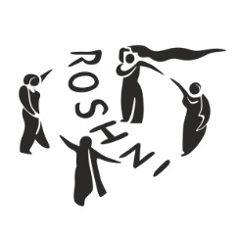

Job vacancy at Roshni Sheffield Asian Women’s Resource Centre

Roshni offers a range of bi-lingual and culturally appropriate services to women from Pakistani, Bangladeshi, and Indian backgrounds, to empower the women with information, guidance, and support to achieve their full potential. We currently have the following vacancy at Roshni:

Female English Literacy Tutor

Salary: £30,788 (pro rata £12,482 ) £16.00 per hour
Hours: 15 per week

Funded for 1 year

Purpose and scope of the job: To be responsible for delivering and coordinating community-based English classes for South Asian women whose first language is not English. The role aims to support marginalised women to overcome barriers, build confidence, and improve their English language skills to enable them to thrive within their families and communities, including supporting women to progress into formal accredited ESOL classes.
The post holder will need an understanding of the cultural and social barriers many women face in accessing education, maintaining attendance, and sustaining motivation. They will be expected to create supportive learning environments, develop individual learning goals, and encourage women to progress and achieve their potential.
The successful candidate will contribute to the development of a basic literacy programme for women with little or no formal education and will adapt teaching approaches to meet a wide range of learning needs and abilities.
A formal ESOL (English for Speakers of Other Languages) teaching qualification is desirable but not essential. Applications are welcomed from individuals who can demonstrate relevant experience, knowledge, and the qualities needed to successfully undertake this role. The ability to speak a relevant community language is desirable but not an essential requirement for this position.

To apply, please use the attached application pack, and email the completed application form to ghazala@roshnisheffield.org.uk

Application deadline: Tuesday 9th June 2026
Interviews: Monday 15th June 2026 (am)

For more information about Roshni, please visit our website: www.roshnisheffield.org.uk. This post is open to female applicants only as being female is deemed to be a genuine occupational requirement under Schedule 9, Paragraph 1 of the Equality Act 2010.

