Job vacancy at Roshni Sheffield Asian Women’s Resource Centre
Roshni offers a range of bi-lingual and culturally appropriate services to women from Pakistani, Bangladeshi and Indian backgrounds, to empower the women with information, guidance and support to achieve their full potential. We currently have the following vacancy at Roshni:

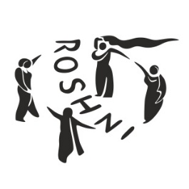
Training and Engagement Worker (female with one of these community languages: Urdu/Punjabi/Hindi)
Salary: Full time £30,788. £14,978 for 18 hrs
Length of Contract: 22 months, ending Nov 2027
Hours: 18 per week
Purpose and scope of the job:

Roshni’s Empowerment Circle Project offers a comprehensive range of holistic support services for vulnerable women. These include advocacy, skills training, coaching, and emotional wellbeing support.

The Training and Engagement Worker will benefit from extensive in-house training designed to build practical expertise in counselling skills, coaching, and trauma-informed approaches. This role involves applying these skills to support women who have experienced disempowerment, helping them to build confidence, develop new skills, and strengthen their resilience through both one-to-one and group-based interventions.

An important aspect of the role includes engaging with external support organisations to enhance the reach and impact of the project, ensuring women have access to a broader network of welfare services.

This is primarily an office-based position that requires regular face-to-face interaction with service users. While some flexibility may be possible, remote working options are limited due to the nature of the role.

To apply, please use the attached application pack, and email the completed application form to fouzia@roshnisheffield.org.uk

Application deadline: Wednesday 21 January 2026, 10 am
Interviews: Monday 26 January 2026

For more information about Roshni, please visit our website: www.roshnisheffield.org.uk

